Melissa Webb
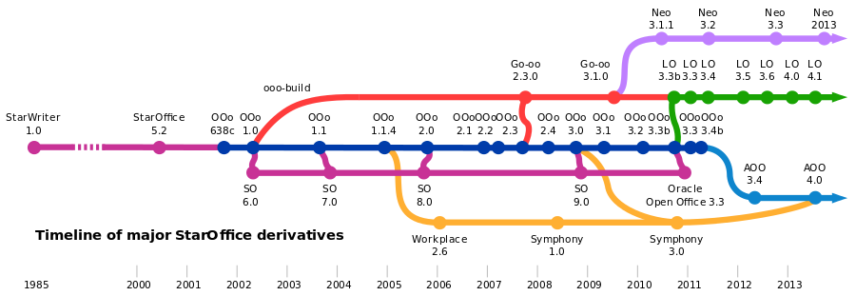
June 18, 2015

